**OUTPUT:**

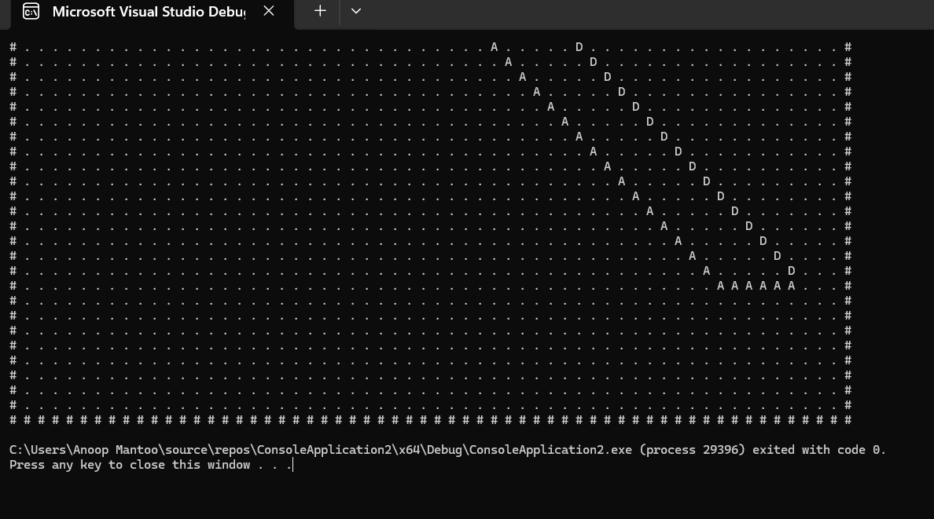

**SOURCE CODE [CONSOLE BASED]:**

#include <iostream>

#include <vector>

#include <queue>

#include <cmath>

#include <limits>

#include <set>

using namespace std;

#define num 60

// Dijkstra's Pathfinding

vector<pair<int, int>> pathD;

bool sptSet[num][num];

void findmin(float dist[num][num], int& min_x, int& min_y) {

float mini = numeric_limits<float>::max();

for (int i = 0; i < num; i++)

for (int j = 0; j < num; j++)

if (!sptSet[i][j] && dist[i][j] < mini) {

mini = dist[i][j];

min_x = i;

min_y = j;

}

}

void findpath(pair<int, int> previous[num][num], float dist[num][num], int dest_x, int dest_y, int source_x, int source_y) {

cout << "\nLength of Dijkstra path is: " << dist[dest_x][dest_y] << endl;

while (previous[dest_x][dest_y].first != source_x || previous[dest_x][dest_y].second != source_y) {

pathD.push_back(make_pair(previous[dest_x][dest_y].first, previous[dest_x][dest_y].second));

int save_x = dest_x, save_y = dest_y;

dest_x = previous[save_x][save_y].first;

dest_y = previous[save_x][save_y].second;

}

}

void dijkstra(int source_x, int source_y, int dest_x, int dest_y, int grid[num][num]) {

pair<int, int> previous[num][num];

float dist[num][num];

for (int i = 0; i < num; i++)

for (int j = 0; j < num; j++)

dist[i][j] = numeric_limits<float>::max();

dist[source_x][source_y] = 0.0;

int found = 0;

for (int i = 0; i < num && found == 0; i++) {

for (int j = 0; j < num && found == 0; j++) {

int min_x = 0, min_y = 0;

findmin(dist, min_x, min_y);

sptSet[min_x][min_y] = true;

if (sptSet[dest_x][dest_y] == true) {

found = 1;

break;

}

int possibleX[] = { 0, 0, 1, -1, 1, -1, -1, 1 };

int possibleY[] = { 1, -1, 0, 0, 1, 1, -1, -1 };

for (int i = 0; i < 8; ++i) {

int newRow = min_x + possibleX[i];

int newCol = min_y + possibleY[i];

if (newRow >= 0 && newRow < num && newCol >= 0 && newCol < num && grid[newRow][newCol] == 1 && !sptSet[newRow][newCol] && dist[newRow][newCol] > dist[min_x][min_y] + 1.0) {

dist[newRow][newCol] = dist[min_x][min_y] + 1.0;

previous[newRow][newCol] = make_pair(min_x, min_y);

}

}

}

}

findpath(previous, dist, dest_x, dest_y, source_x, source_y);

}

// A* Pathfinding

typedef pair<int, int> Pair;

typedef pair<float, pair<int, int>> Ppair;

bool closedList[num][num];

vector<Pair> pathA;

struct cell {

int parent_x, parent_y;

float f, g, h;

cell() : f(numeric_limits<float>::max()), g(numeric_limits<float>::max()), h(numeric_limits<float>::max()), parent_x(-1), parent_y(-1) {};

};

bool isDestination(int row, int col, Pair dest) {

return row == dest.first && col == dest.second;

}

float calculateHvalue(int row, int col, Pair dest) {

int dx = abs(dest.first - row);

int dy = abs(dest.second - col);

return abs(dx - dy) + sqrt(2) * min(dx, dy);

}

void tracePath(Pair source, Pair dest, cell cellDetails[][num]) {

int i = cellDetails[dest.first][dest.second].parent_x, j = cellDetails[dest.first][dest.second].parent_y;

while (!(i == source.first && j == source.second)) {

pathA.push_back(make_pair(i, j));

int temp_i = i;

int temp_j = j;

i = cellDetails[temp_i][temp_j].parent_x;

j = cellDetails[temp_i][temp_j].parent_y;

}

cout << "\nLength of A* path(g) is: " << cellDetails[dest.first][dest.second].g << endl;

}

void Astar(Pair source, Pair dest, int grid[][num]) {

set<Ppair> openList;

cell cellDetails[num][num];

int i = source.first, j = source.second;

cellDetails[i][j].f = 0.0;

cellDetails[i][j].g = 0.0;

cellDetails[i][j].h = 0.0;

cellDetails[i][j].parent_x = i;

cellDetails[i][j].parent_y = j;

openList.insert(make_pair(0.0, make_pair(i, j)));

bool destFound = false;

int possibleX[] = { 0, 0, 1, -1, 1, -1, -1, 1 };

int possibleY[] = { 1, -1, 0, 0, 1, 1, -1, -1 };

while (!openList.empty()) {

Ppair p = *openList.begin();

openList.erase(openList.begin());

int i = p.second.first, j = p.second.second;

closedList[i][j] = true;

if (isDestination(i, j, dest)) {

destFound = true;

break;

}

for (int k = 0; k < 8; ++k) {

int newRow = i + possibleX[k];

int newCol = j + possibleY[k];

if (newRow >= 0 && newRow < num && newCol >= 0 && newCol < num && grid[newRow][newCol] == 1 && !closedList[newRow][newCol]) {

cell successor;

successor.g = cellDetails[i][j].g + 1.0;

successor.h = calculateHvalue(newRow, newCol, dest);

successor.f = successor.g + successor.h;

successor.parent_x = i;

successor.parent_y = j;

if (cellDetails[newRow][newCol].g > successor.g) {

cellDetails[newRow][newCol] = successor;

openList.insert(make_pair(successor.f, make_pair(newRow, newCol)));

}

}

}

}

if (!destFound)

cout << "Destination cell not found.\n";

else

tracePath(source, dest, cellDetails);

}

// Main function

int main() {

int filled[num][num];

int grid[num][num];

for (int i = 0; i < num; i++)

for (int j = 0; j < num; j++) {

if (i == 0 || i == num - 1 || j == 0 || j == num - 1)

grid[i][j] = 0;

else

grid[i][j] = 1;

}

for (int i = 0; i < num; i++)

for (int j = 0; j < num; j++) {

sptSet[i][j] = false;

filled[i][j] = 0;

}

memset(closedList, false, sizeof(closedList));

int source_x = 2, source_y = 2, dest_x = 50, dest_y = 56;

// Run Dijkstra's and A* algorithms

dijkstra(source_x, source_y, dest_x, dest_y, grid);

Astar(make_pair(source_x, source_y), make_pair(dest_x, dest_y), grid);

// Display results in console

cout << "Grid with paths:\n";

for (int i = 0; i < num; i++) {

for (int j = 0; j < num; j++) {

if (find(pathD.begin(), pathD.end(), make_pair(i, j)) != pathD.end())

cout << "D "; // Path found by Dijkstra's

else if (find(pathA.begin(), pathA.end(), make_pair(i, j)) != pathA.end())

cout << "A "; // Path found by A*

else if (grid[i][j] == 0)

cout << "# "; // Obstacle

else

cout << ". "; // Empty space

}

cout << endl;

}

return 0;

}